Central Angle  Θ = intercepted arc  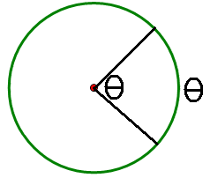 | Inscribed Angle  Θ = half the intercepted arc  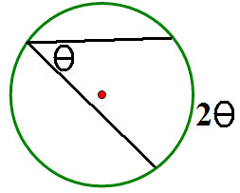 | Hypotenuse of Inscribed Right Triangle is Diameter  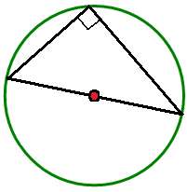
Two angles that share the same intercepted arc are congruent.  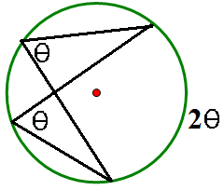 | Opposite angles of inscribed quadrilateral are supplementary.  a + b = 180°; c + d = 180°  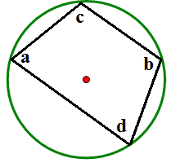 | Diameter bisects a perpendicular chord and its arc.  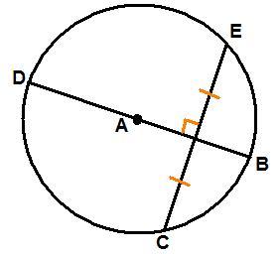
Two minor arcs are congruent if their corresponding chords are congruent.  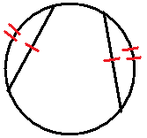 | Two chords are congruent if their midpoints are equidistant from the center.  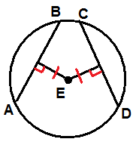 | A tangent is perpendicular to the radius of a circle.  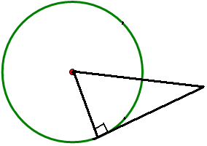
Tangent segments from a common external point are congruent.  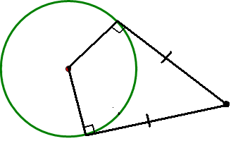 | $$Arc Length =\frac{A°}{360°}(Circumference)$$  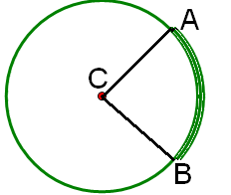 | $$Sector Area =\frac{A°}{360°}(Area)$$  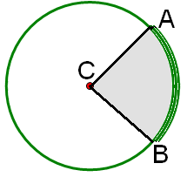
Angle with vertex on the circle  Θ = ½ a  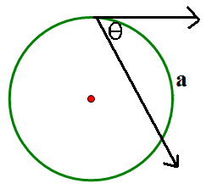 | Angle with vertex inside circle  Θ = ½ (a + b)  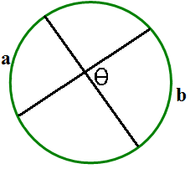 | Angle with vertex outside circle.  Θ = ½ (d - c)  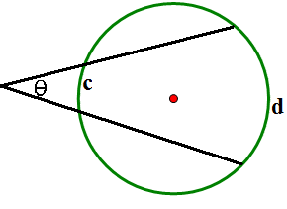
Segments intersecting inside circle  ab = cd  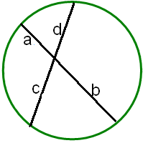 | Segments intersecting outside circle  a(a+b) = c(c+d)  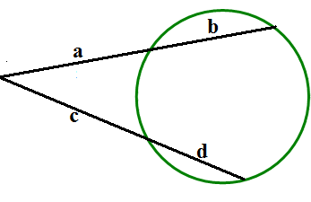 | Tangent and segment  a² = b(b+c)  